**Getting to know IN-CORE 2.0**

NCSA Team, [incore-dev@lists.illinois.edu](mailto:incore-dev@lists.illinois.edu)

Table of Contents

1 Acquiring IN-CORE account 2

2 Installing pyIncore 3

2.1 Prerequisites 3

2.2 Windows 64-bit 4

2.3 Mac OS 5

2.4 Linux 7

3 Testing pyIncore Installation 8

3.1 Running a Building Damage Analysis Locally 8

4 Using IN-CORE Lab 10

4.1 Running Jupyter Notebook in IN-CORE Lab 10

5 How to Contact and Work with NCSA 12

6 Information for pyIncore Developers 12

7 Additional Information 13

7.1 Technical Documentation 13

7.2 IN-CORE Web tools 14

7.3 Additional Information about IN-CORE Lab 16

# Acquiring IN-CORE account

* A user must have a valid IN-CORE account recognized by theIN-CORE service. Please **register** at <https://identity.ncsa.illinois.edu/register/UUMK36FU2M>
* Your credentials (Username and Password) will be required in later steps.

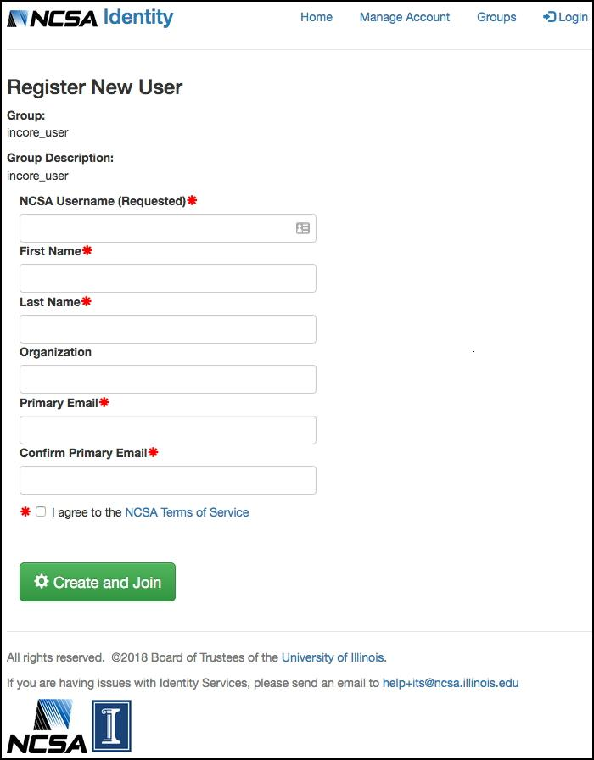

NOTE: Use your institutional email if possible.

* The username/password is used for accessing IN-CORE services. You can test your registration credentials by accessing the **IN-CORE page** at: <https://incore2.ncsa.illinois.edu/>.
* This is also used for accessing the **documentation** and downloading pyIncore package (**pyincore_0.3.0.tar.gz**) and Jupyter Notebook test file (**buildingdamage.ipynb**) at <http://incore2.ncsa.illinois.edu/>.

# Installing pyIncore

## Prerequisites

Please read through the instructions at least once completely before actually following them to avoid any installation problems!

**IN-CORE account**

* A user must have an IN-CORE account. If you don’t have an account, see IN-CORE account section above.

**Python 3.5+** (<https://www.python.org)>

* If you are on Windows, go to Windows 64 bit section.
* It is common to have more than one Python version installed on your computer. Make sure you are running the correct version of Python (you can check by running python --version) with corresponding path added to the PATH system variable. The following links will help you navigate through various installations guides
  + <https://realpython.com/installing-python/>
  + <https://docs.python-guide.org/#the-hitchhiker-s-guide-to-python>
  + OS specific downloads: <https://www.python.org/downloads/>

**Virtual environment**

We recommend that users get familiar with virtual environments (<https://www.pythonforbeginners.com/basics/how-to-use-python-virtualenv/>) or environment manager (<https://www.anaconda.com/distribution/)>;

* These are tools that help keep dependencies separate for different projects. If you decide, however, to use a virtual environment or manager you must do it now, in this prerequisite step.
* A module named virtualenv  is available by running pip3 install virtualenv (pip3 command is pip for Python3, you could also run pip3 install --upgrade pip first),  
  **OR**
* An environment manager called Anaconda by downloading OS specific installer (<https://docs.anaconda.com/anaconda/install/)> Note that a full Anaconda distribution will include Python (and a collection of over 1,500+ open source packages), so installing Python first isn't needed if you use Anaconda. With Anaconda you already have installed Jupyter notebook. The conda is the preferred interface for managing installations and virtual environments with the Anaconda Python distribution.

**Jupyter notebook** (<https://jupyter.org/)>

We recommend using Jupyter Notebook for ease of running **pyIncore** projects. It is an open-source application that allows you to create projects (documents) that contain live Python code, visualizations and documentation.

* Installing Jupyter (<https://jupyter.org/install.html>) can be done again with pip (on Miniconda; in your virtual environment) or pip3 as indicated below:

pip3 install jupyter

**pyIncore** uses the Geospatial Data Abstraction Library (GDAL) (<https://www.gdal.org>), which has to be installed separately. Note that GDAL installation is global on Windows and Linux, even if you use virtual environments (see next step).

## Windows 64-bit

**GDAL** (<https://www.gdal.org>) - Geospatial Data Abstraction Library

We provide installation instructions for Anaconda environment manager using Miniconda (<https://docs.conda.io/en/latest/miniconda.html>). Python 3.x and GDAL library will be installed with Miniconda. The following instructions were tested for Windows 64-bit (The 32-bit has not been tested yet):

1. Download the latest Miniconda3 installer for Windows from the Miniconda web page. (<https://docs.conda.io/en/latest/miniconda.html>)
2. Run the installer setup locally (select the “Just Me” choice) to avoid the need for administrator privileges.
3. Leave the default folder path (C:\Users\<user>\..\miniconda3).
4. Do not add Anaconda to the PATH. Do, however, register Anaconda as the default Python environment.
5. Open up an Anaconda prompt from the Windows Start menu. The base environment is being activated and the prompt changes to: (base) C:\Users\<user>
6. Create the python environment (pyincore) and activate it (or stay in the base):

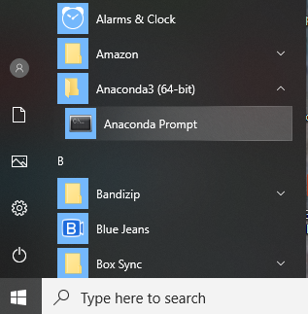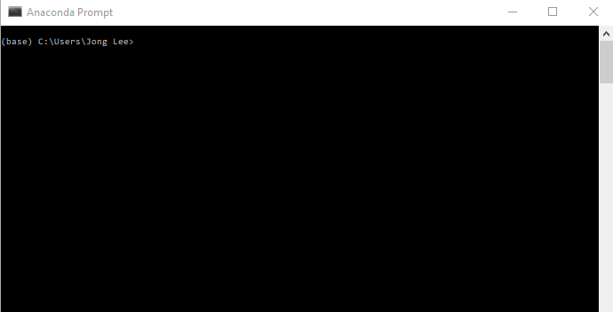

1. Create the python environment (required for the pyincore) and activate it:

conda create -n pyincore python=3

conda activate pyincore

1. Install dependency packages in the following order:

conda install rasterio

conda install fiona

conda install rtree

**pyIncore package**

These steps will guide you on how to install pyIncore.

1. Download pyIncore (pyincore_<version>.tar.gz) at <https://incore2.ncsa.illinois.edu/> to a directory on your computer.
2. To install pyIncore, navigate to the directory you used on step 1 and:

From the Anaconda prompt run:

* If you are using a virtual environment, you will need to activate it if it has not been done yet.
* Run the following command:

pip3 install --user pyincore_<version>.tar.gz

**pyIncore credentials**

The installation installs **pyIncore** and creates an .incore folder in your HOME directory to store cached files. A message pyIncore credentials file has been created at <HOME directory>/.incore/.incorepw appears in the prompt. The typical location of a HOME directory is C:\Users\<username> on Windows OS.

1. Locate a file called **.incorepw** in the .incore folder in your HOME directory.
2. Write your LDAP credentials in it; the first line contains your username and the second password. This information is used for communicating with IN-CORE web service.

## Mac OS

**GDAL** (<https://www.gdal.org>) - Geospatial Data Abstraction Library

Use Homebrew (<http://mxcl.github.com/homebrew/>), a MacOS package manager. If you don’t have Homebrew, please install it. Additional information about installing GDAL can be found at <https://medium.com/@vascofernandes_13322/how-to-install-gdal-on-macos-6a76fb5e24a4>

1. Install **gdal**:

brew install gdal

1. Install **spatialindex** library

brew install spatialindex

1. Also, update your pip Python package manager

pip3 install --upgrade pip

**pyIncore package**

These steps will guide you on how to install pyIncore.

1. Download pyIncore (pyincore_<version>.tar.gz) at <https://incore2.ncsa.illinois.edu/> to a directory on your computer.
2. To install pyIncore, navigate to the directory you used on step 1 and:

* If you are using a virtual environment, you will need to activate it if it has not been done yet.
* Run the following command:

pip3 install --user pyincore_<version>.tar.gz

* We use the matplotlib library to create graphs. There is a Mac specific installation issue addressed at StackOverflow <https://stackoverflow.com/questions/4130355/python-matplotlib-framework-under-macosx> and <https://stackoverflow.com/questions/21784641/installation-issue-with-matplotlib-python>. In a nutshell, insert line

backend: Agg

into the ~/.matplotlib/matplotlibrc file. You must create the file (matplotlibrc) if it does not exist.

**pyIncore credentials**

The installation installs **pyIncore** and creates an .incore folder in your HOME directory to store cached files. A message pyIncore credentials file has been created at <HOME directory>/.incore/.incorepw appears in the prompt. The typical location of a HOME directory is /Users/<username> on Mac OS.

**Note**: The folders and files starting with "." (dot prefix) are hidden in Operating systems with Unix roots. There are few ways (<https://nektony.com/how-to/show-hidden-files-on-mac> and <https://macpaw.com/how-to/show-hidden-files-on-mac>) to view hidden files on your Mac.

1. Locate a file called **.incorepw** in the .incore folder in your HOME directory.
2. Write your LDAP credentials in it; the first line contains your username and the second password. This information is used for communicating with IN-CORE web service.

## Linux

**GDAL** (<https://www.gdal.org>) - Geospatial Data Abstraction Library

Additional information about installing GDAL can be found at <https://github.com/domlysz/BlenderGIS/wiki/How-to-install-GDAL>).

1. Install **gdal-bin**:

sudo apt-get install gdal-bin

1. Install **libspatialindex-dev** library

apt-get install libspatialindex-dev

1. Also, update your pip Python package manager

pip3 install --upgrade pip

**pyIncore package**

These steps will guide you on how to install pyIncore.

1. Download pyIncore (pyincore_<version>.tar.gz) at <https://incore2.ncsa.illinois.edu/> to a directory on your computer.
2. To install pyIncore, navigate to the directory you used on step 1 and:

* If you are using a virtual environment, you will need to activate it if it has not been done yet.
* Run the following command:

pip3 install --user pyincore_<version>.tar.gz

* If you see the *OSError: Could not find libspatialindex_c library file* error, make sure that you installed **libspatialindex-dev** (see GDAL section above).

**pyIncore credentials**

The installation installs **pyIncore** and creates an .incore folder in your HOME directory to store cached files. A message pyIncore credentials file has been created at <HOME directory>/.incore/.incorepw appears in the prompt. The typical location of a HOME directory is /home/<username> on Linux based machines.

**Note**: The folders and files starting with "." (dot prefix) are hidden in Operating systems with Unix roots.

1. Locate a file called **.incorepw** in the .incore folder in your HOME directory.
2. Write your LDAP credentials in it; the first line contains your username and the second password. This information is used for communicating with IN-CORE web service.

# Testing pyIncore Installation

* For these instructions we assume that users develop their python script by using pyIncore in their own **project folder** (create folder if you don’t have one)
* Download the Jupyter Notebook file for Building damage analysis [(https://incore2.ncsa.illinois.edu/doc/examples/buildingdamage.ipynb](https://incore2.ncsa.illinois.edu/doc/examples/buildingdamage.ipynb)) to your **project folder.** We will verify your installation of pyIncore by running this file.

## Running a Building Damage Analysis Locally

* Start a local **Jupyter Notebook** by running the following command in the terminal or command prompt from your **project folder** (change directories to the particular project folder at the command prompt):

jupyter notebook

or if **Jupyter Notebook** is not recognized in Anaconda

python -m notebook

A message *The Jupyter Notebook is running* appears in the terminal/prompt and you should see the notebook dashboard open in your browser. Note that you might be asked to copy/paste a URL into your browser when you connect for the first time as shown below:

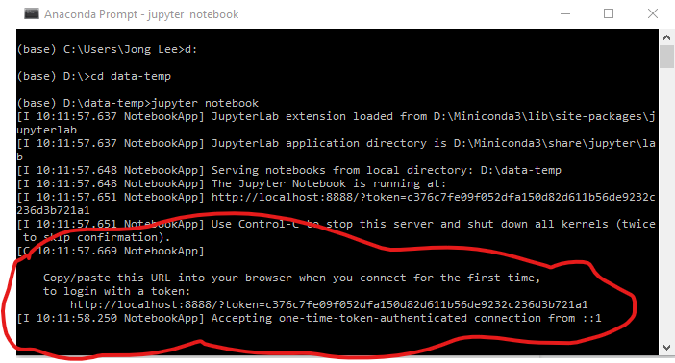

* Click on the buildingdamage.ipynb in the Jupyter Notebook browser.

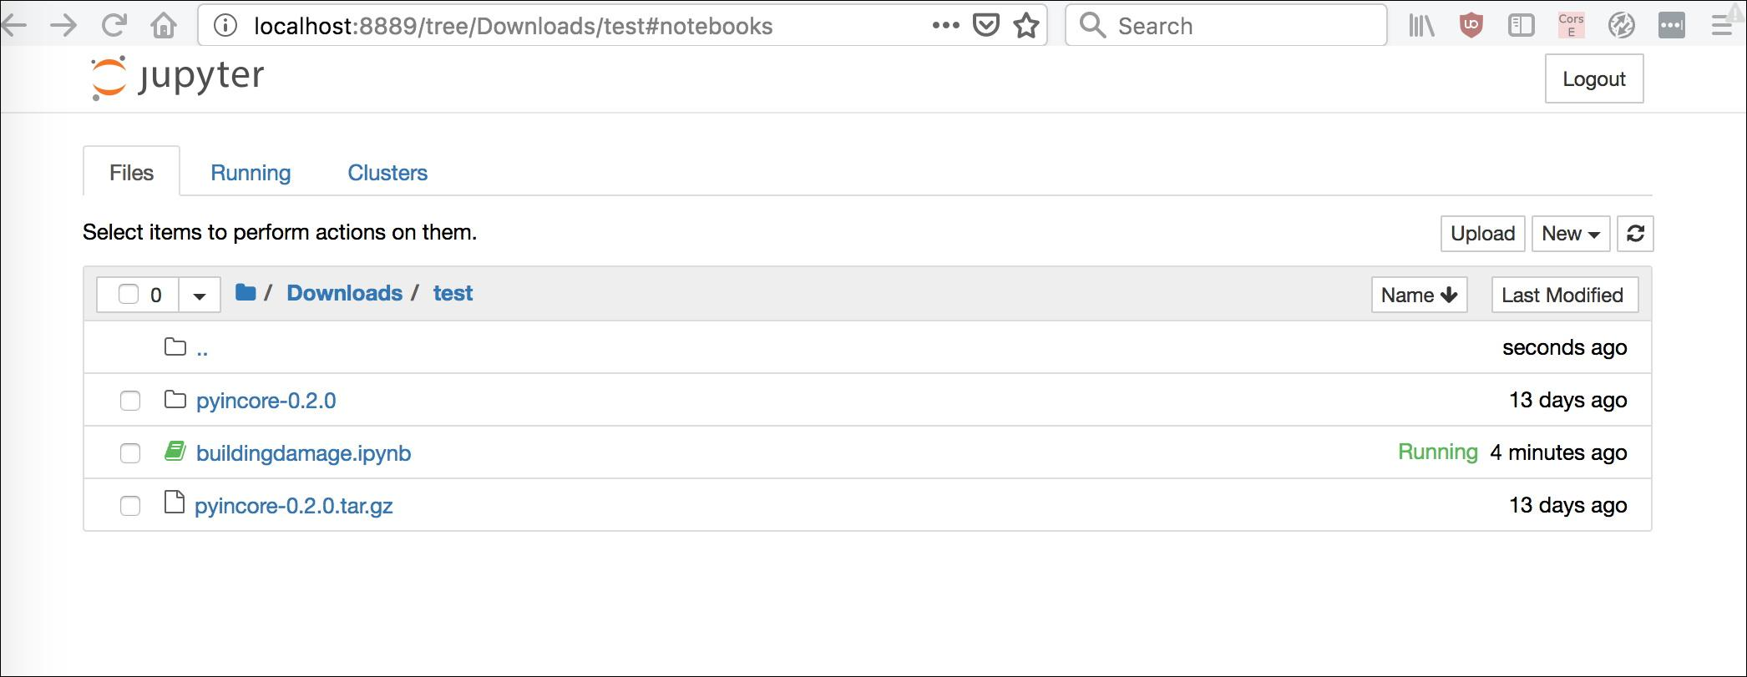

Your web page should now show multiple cells of code like this:

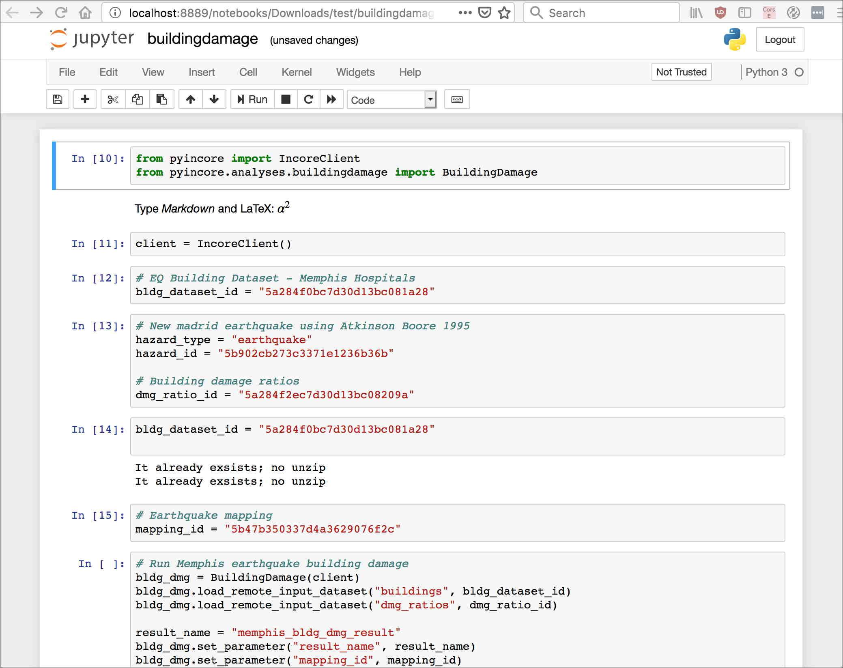

Right now you are not actually running a notebook yet. Running a cell means that you will execute the cell’s contents. To execute cells in order you can just select the first cell and click the ***Run*** button at the top.

Note that **Building damage** is a long running analysis and there is little indication that it's running except by either looking at the Jupyter Notebook file and seeing the [*] for the notebook cell where that block of code is being executed or by looking at the Task Manager in the Notebook dashboard to see there is a python process running. Alternatively, you can look at the Jupyter Notebook dashboard to see if the csv file with results has been created yet.

For details of running and manipulating ipynb files refer to Jupyter documentation (<https://jupyter.readthedocs.io/en/latest/running.html#running>).

# Using IN-CORE Lab

IN-CORE Lab is [a customized Jupyter Lab](https://jupyterlab.readthedocs.io/en/stable/) for running and editing Notebooks accessible at [**https://incore-lab.ncsa.illinois.edu**](https://incore-lab.ncsa.illinois.edu).

* Login to IN-CORE Lab with your IN-CORE account info (you created at the beginning of this session):

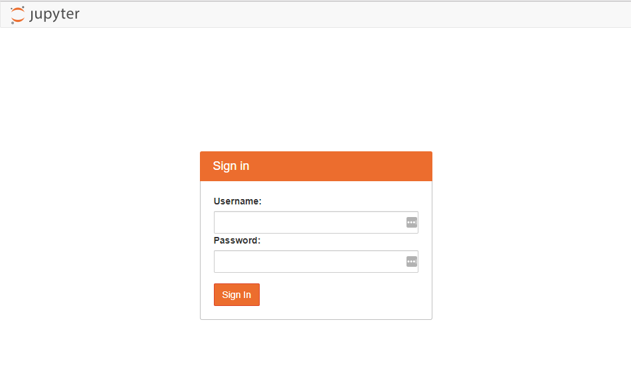

## Running Jupyter Notebook in IN-CORE Lab

In *Testing pyIncore Installation* section we described how to run Building damage Notebook locally. This section focuses on step-by-step instructions of running Notebooks on the IN-CORE Lab.

1. Create a credential file with IN-CORE username/password (same information you used to login to IN-CORE Lab) in order to use IN-CORE services. This is similar to the authentication step described in *Testing pyIncore Installation* section except the authentication file .incorepw is being created on the IN-CORE Lab server running Linux OS:
   1. Open the terminal on IN-CORE lab Launcher page:

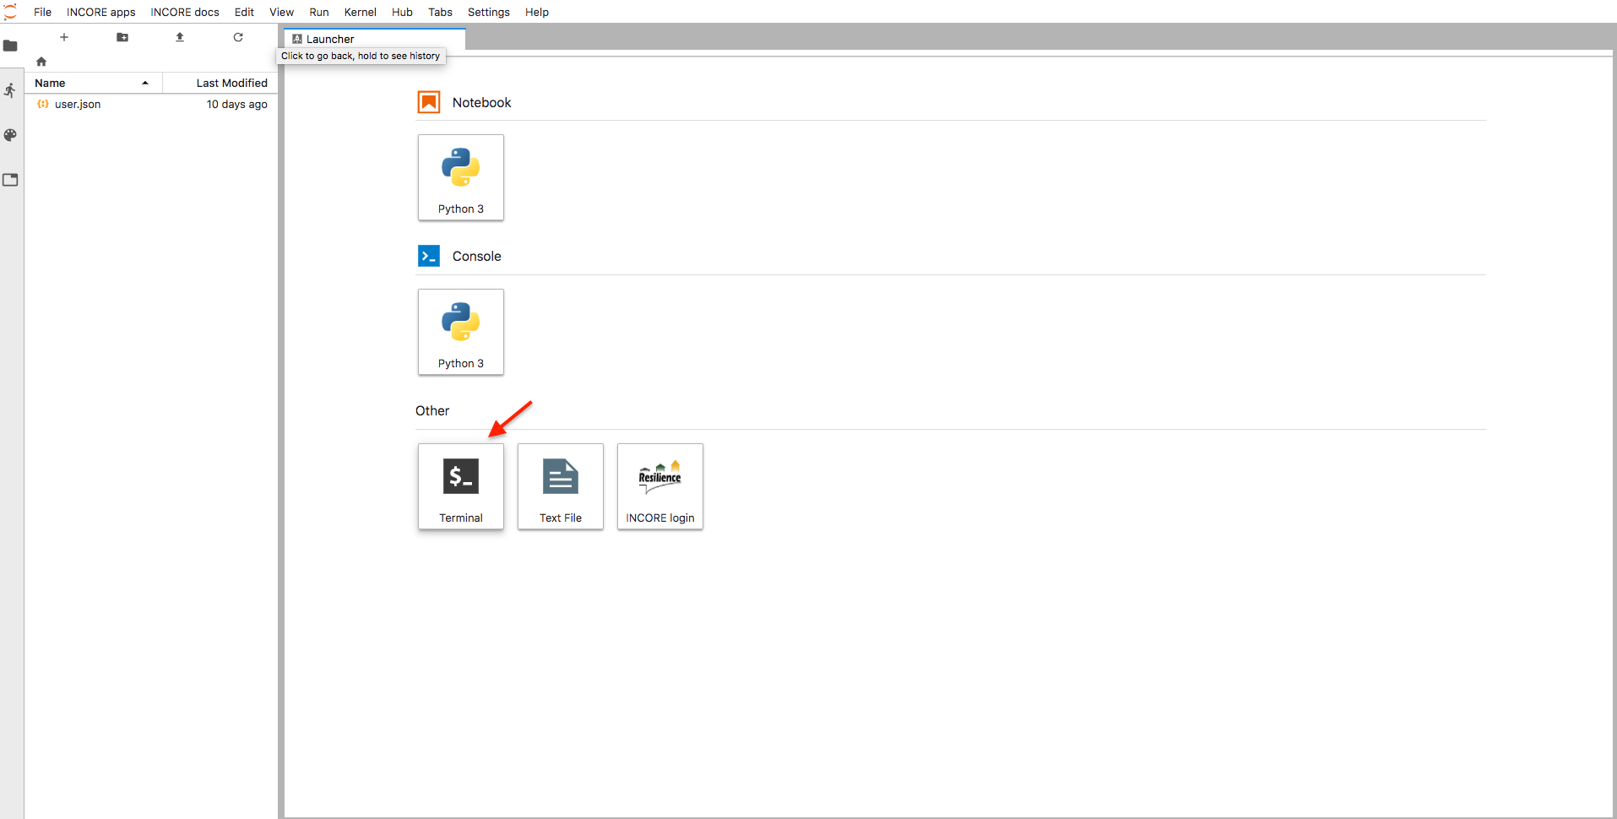

* 1. In the terminal, make sure you are in your HOME directory. Type:

pwd

to see the current path and

cd ~

to get into your home directory (/home/<username>).

* 1. Create a hidden (therefore dot prefix) folder:

mkdir .incore

* 1. Create a hidden credential file in the folder you just created and type IN-CORE username and password using **nano** text editor:

cd .incore

nano .incorepw

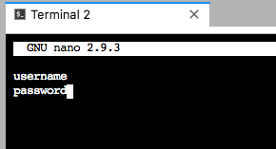

* 1. Save the file with Ctrl+O and Enter commands
  2. Close the text editor and return to your shell with Ctrl+X command

1. Upload the Building Damage Notebook from your local machine to IN-CORE lab by clicking the Upload icon in the left panel and select **buildingdamage.ipybn**.

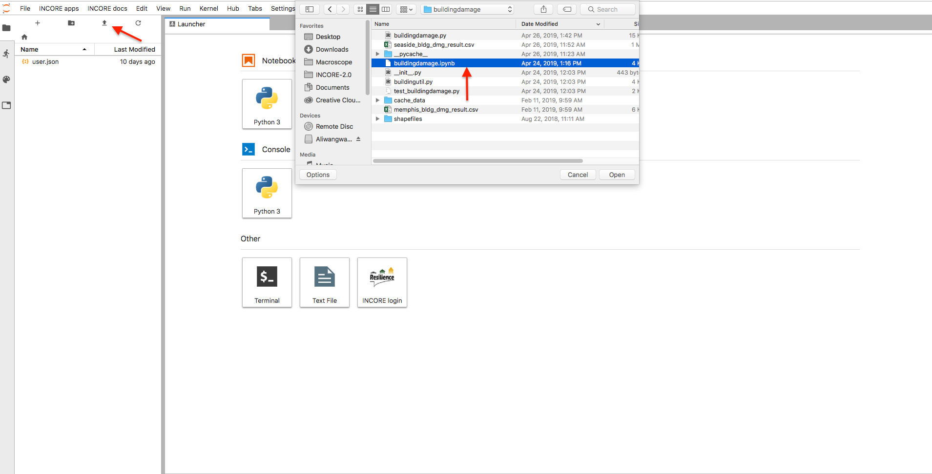

1. The building damage Notebook shows up in the left panel after a successful upload.
2. Double click to open it in the main area.

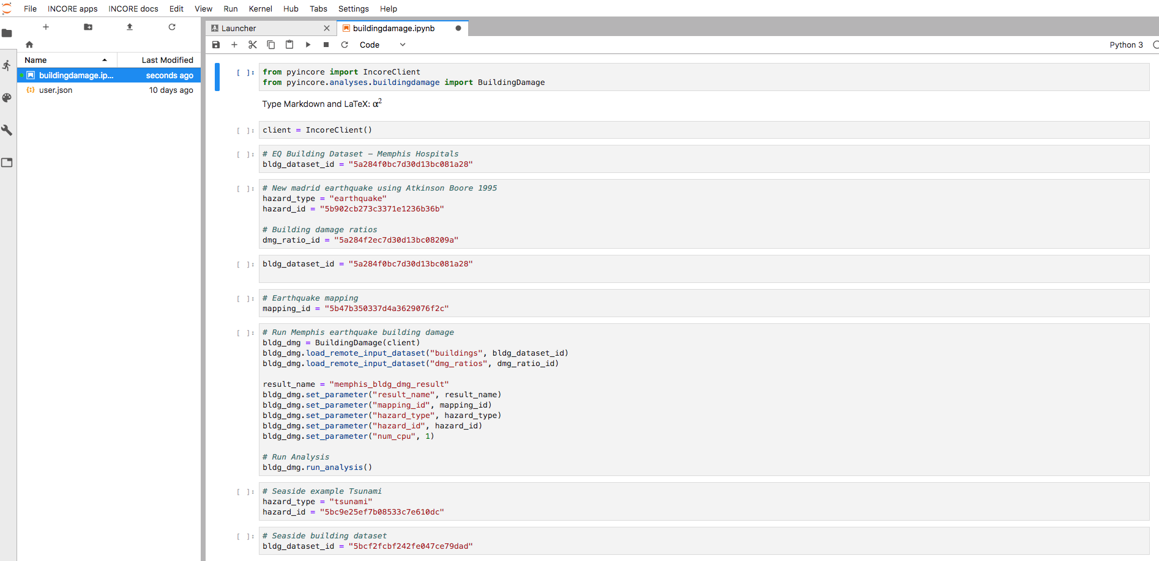

1. Run it. Instructions on how to run building damage analysis, please refer to previous section *Running a Building Damage Analysis*.

# How to Contact and Work with NCSA

* Contact an individual programmer developer by email and copy [incore-dev@lists.illinois.edu](mailto:incore-dev@lists.illinois.edu) if you work closely with NCSA on a code conversion and/or improvement of your hazard analysis.
* Contact the [incore-dev@lists.illinois.edu](mailto:incore-dev@lists.illinois.edu) email list if you do not work directly with NCSA.
* Response time during the week will be in approximately 24 hours or less. Weekend emails will be responded to on the next business day, typically Monday.

# Information for pyIncore Developers

* IN-CORE programming guideline:

<https://opensource.ncsa.illinois.edu/confluence/display/INCORE1/IN-CORE+Programming+Guideline>

* Python programming tips:

<https://opensource.ncsa.illinois.edu/confluence/display/INCORE1/Programming+Tips+for+Python>

# Additional Information

## Technical Documentation

From the IN-CORE landing page at <https://incore2.ncsa.illinois.edu/> a user can access:

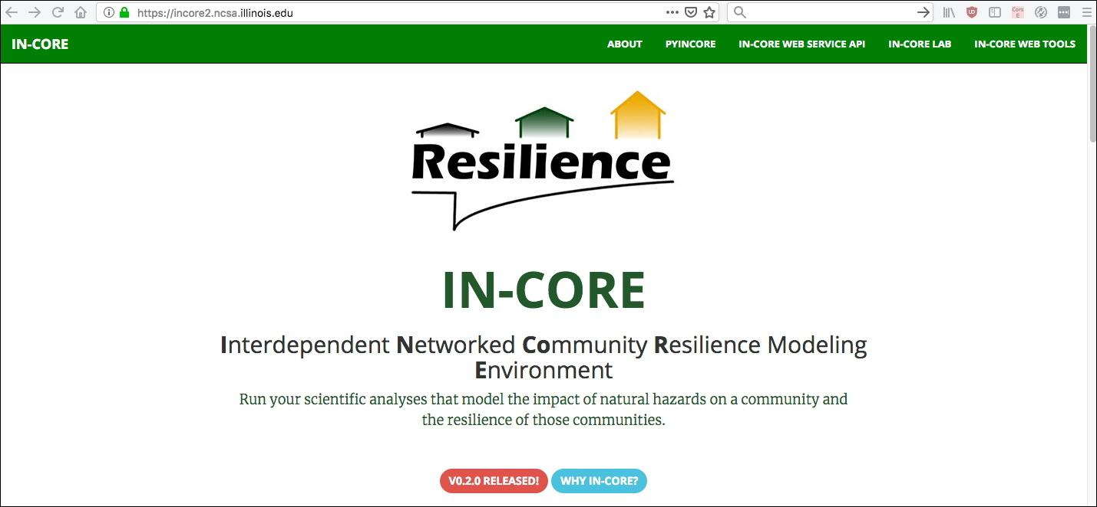

In this site, you can download pyIncore package and access to other services and documentations.

* Documentation of **pyIncore** is at [https://incore2.ncsa.illinois.edu/doc/pyincore/](https://incore2.ncsa.illinois.edu/doc/pyincore/index.html)

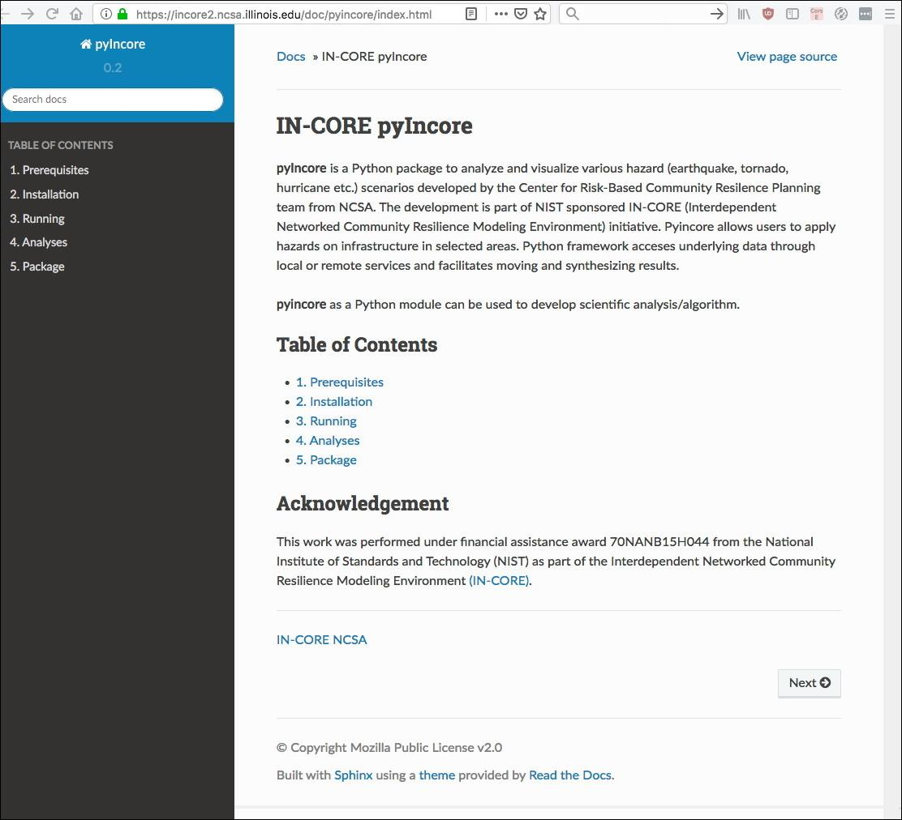

* Documentation of **IN-CORE Web Service** is at <https://incore2.ncsa.illinois.edu/doc/api/>

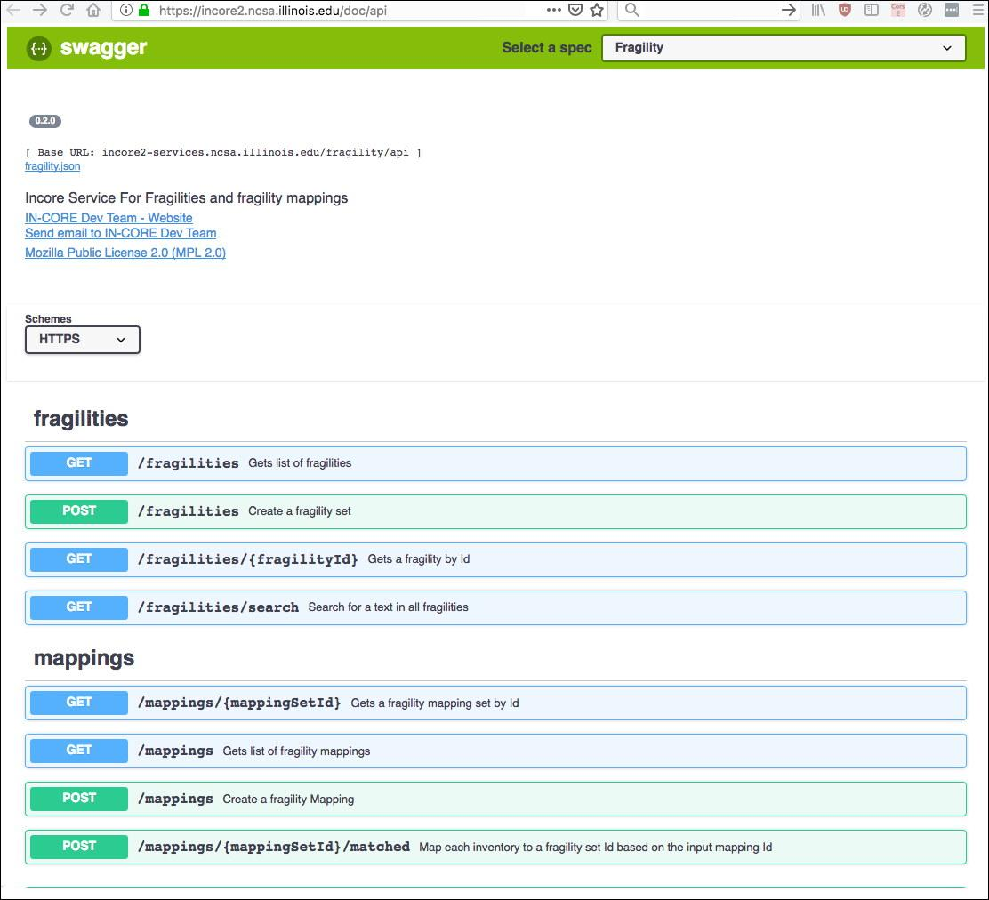

* IN-CORE Lab is at [https://incore-lab.ncsa.illinois.edu](https://incore-lab.ncsa.illinois.edu/)
* IN-CORE Web Tools are for interacting with the service layer. They enable users to browse and search the **Datasets**, **Hazards** and **Fragilities**, view the metadata and visualizations, and download the datasets.

## IN-CORE Web tools

In-Core Web tools refers to a dashboard with viewers for various services. Currently these are **Fragility**, **Data** and **Hazard** services. A user must login with IN-CORE username and password in order to access the viewers:

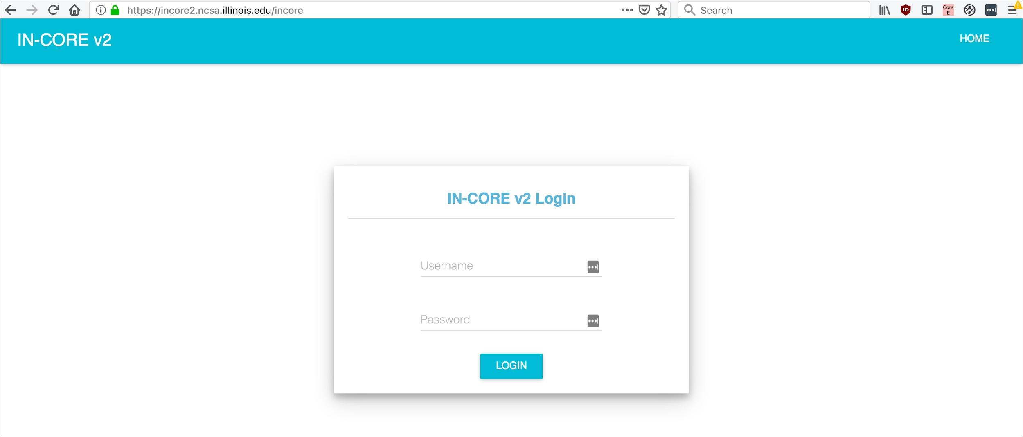

**Fragility service**. This is an example of a viewer showing a selection list (left) of Fragility curves. Hazards and types of structures are selected in the pull down menus. The data can be downloaded in json format.

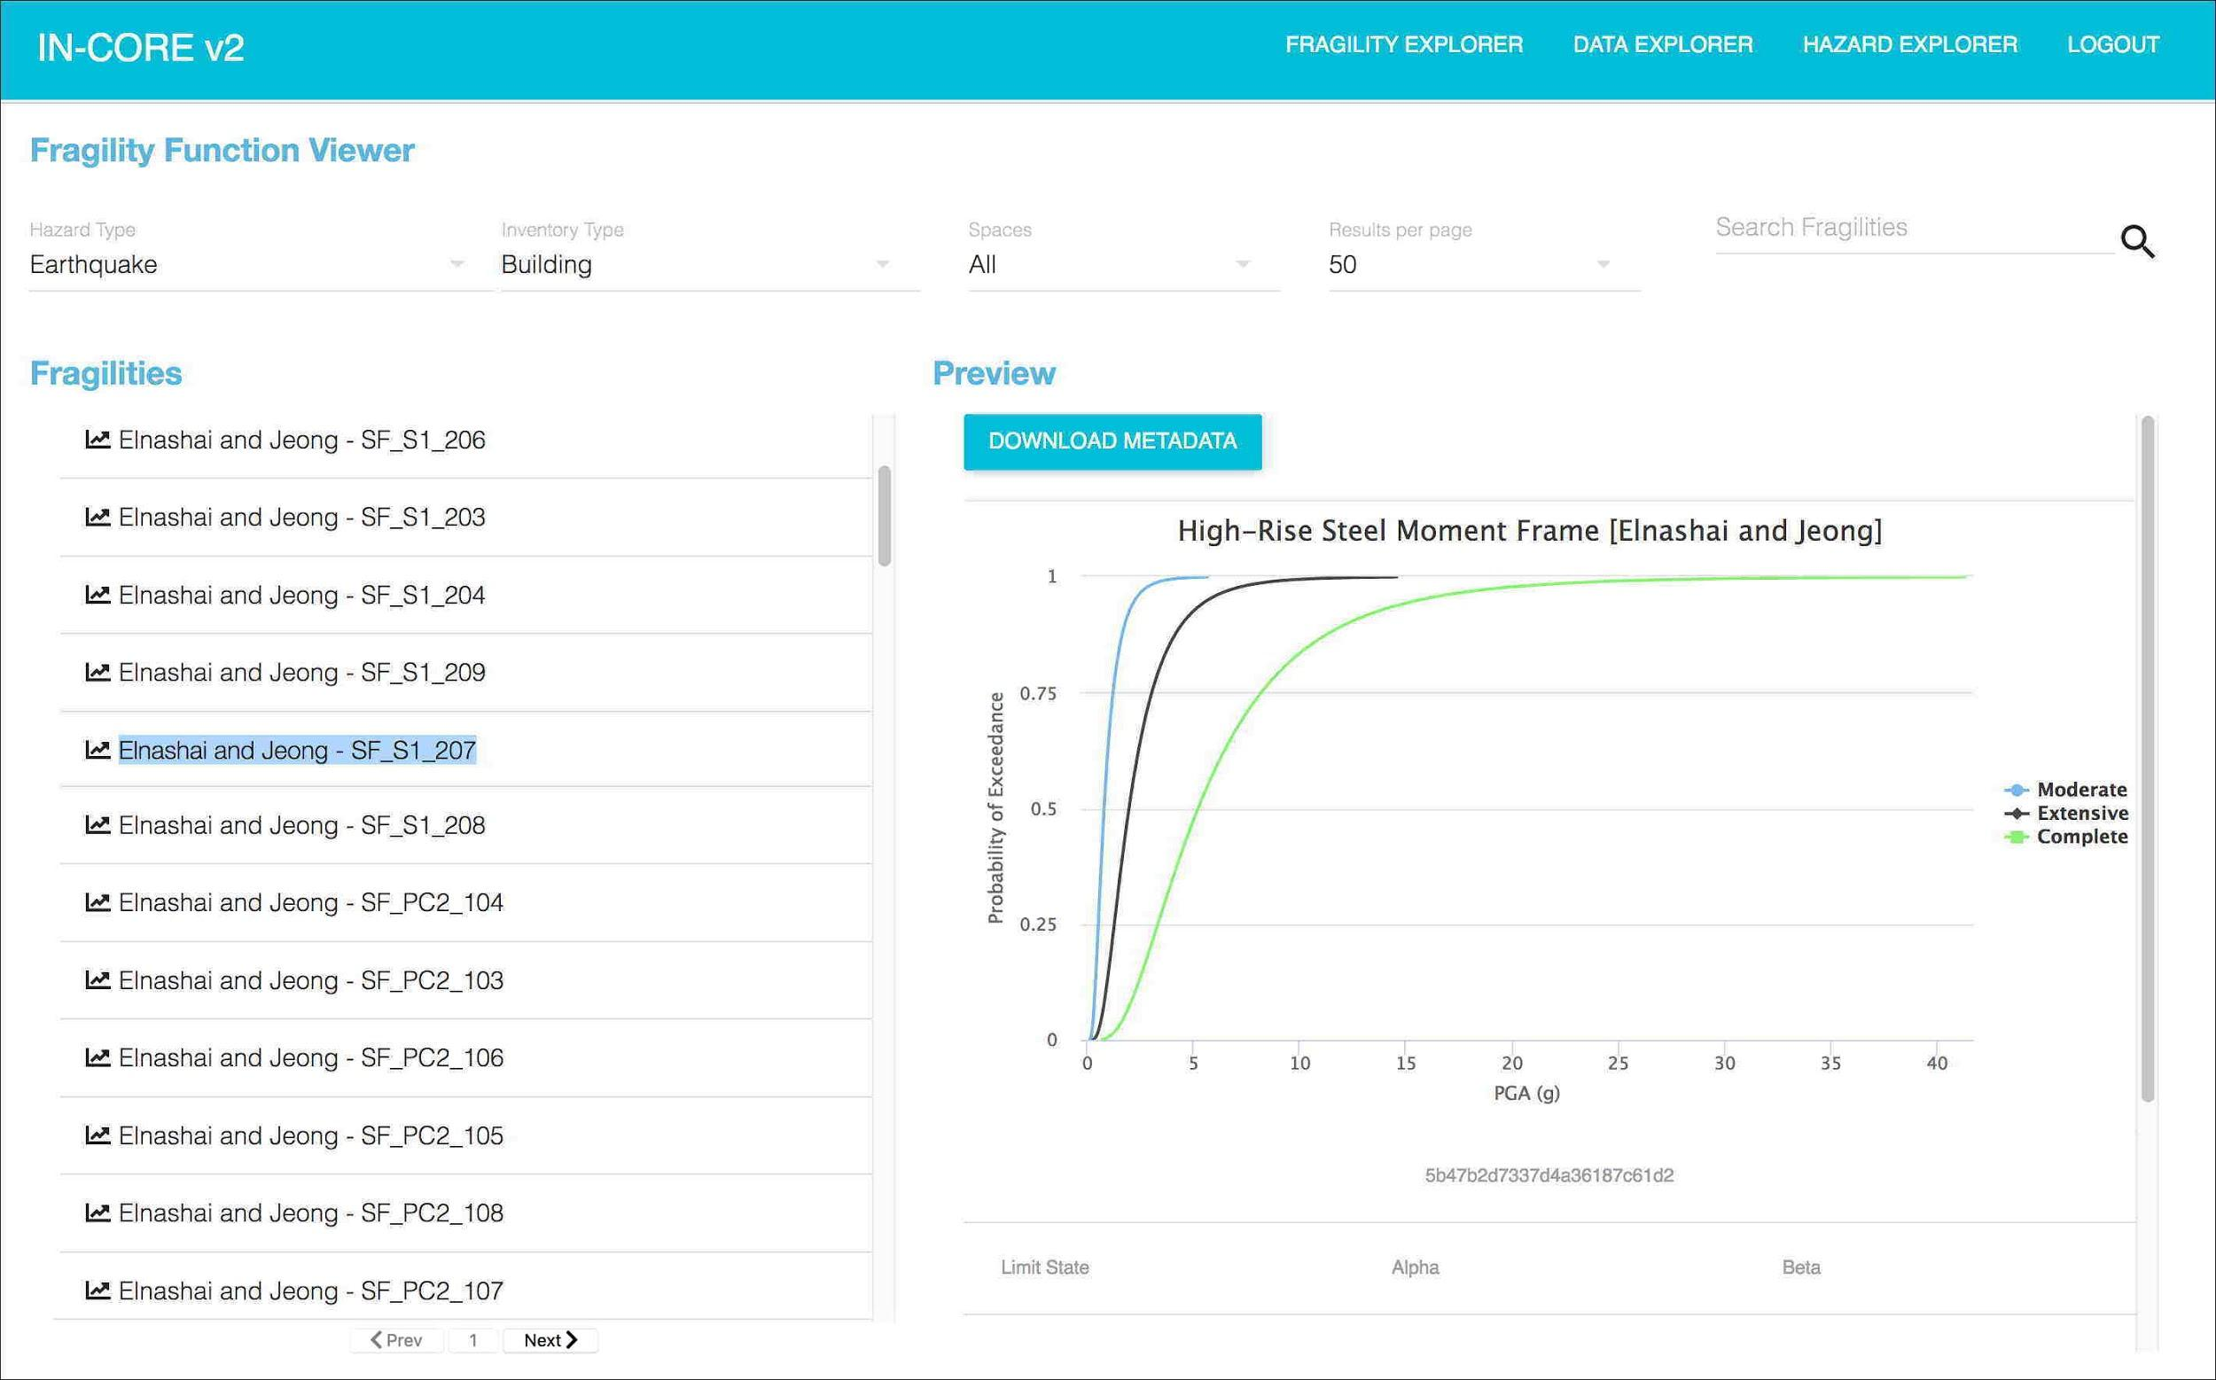

**Hazard service** viewer.

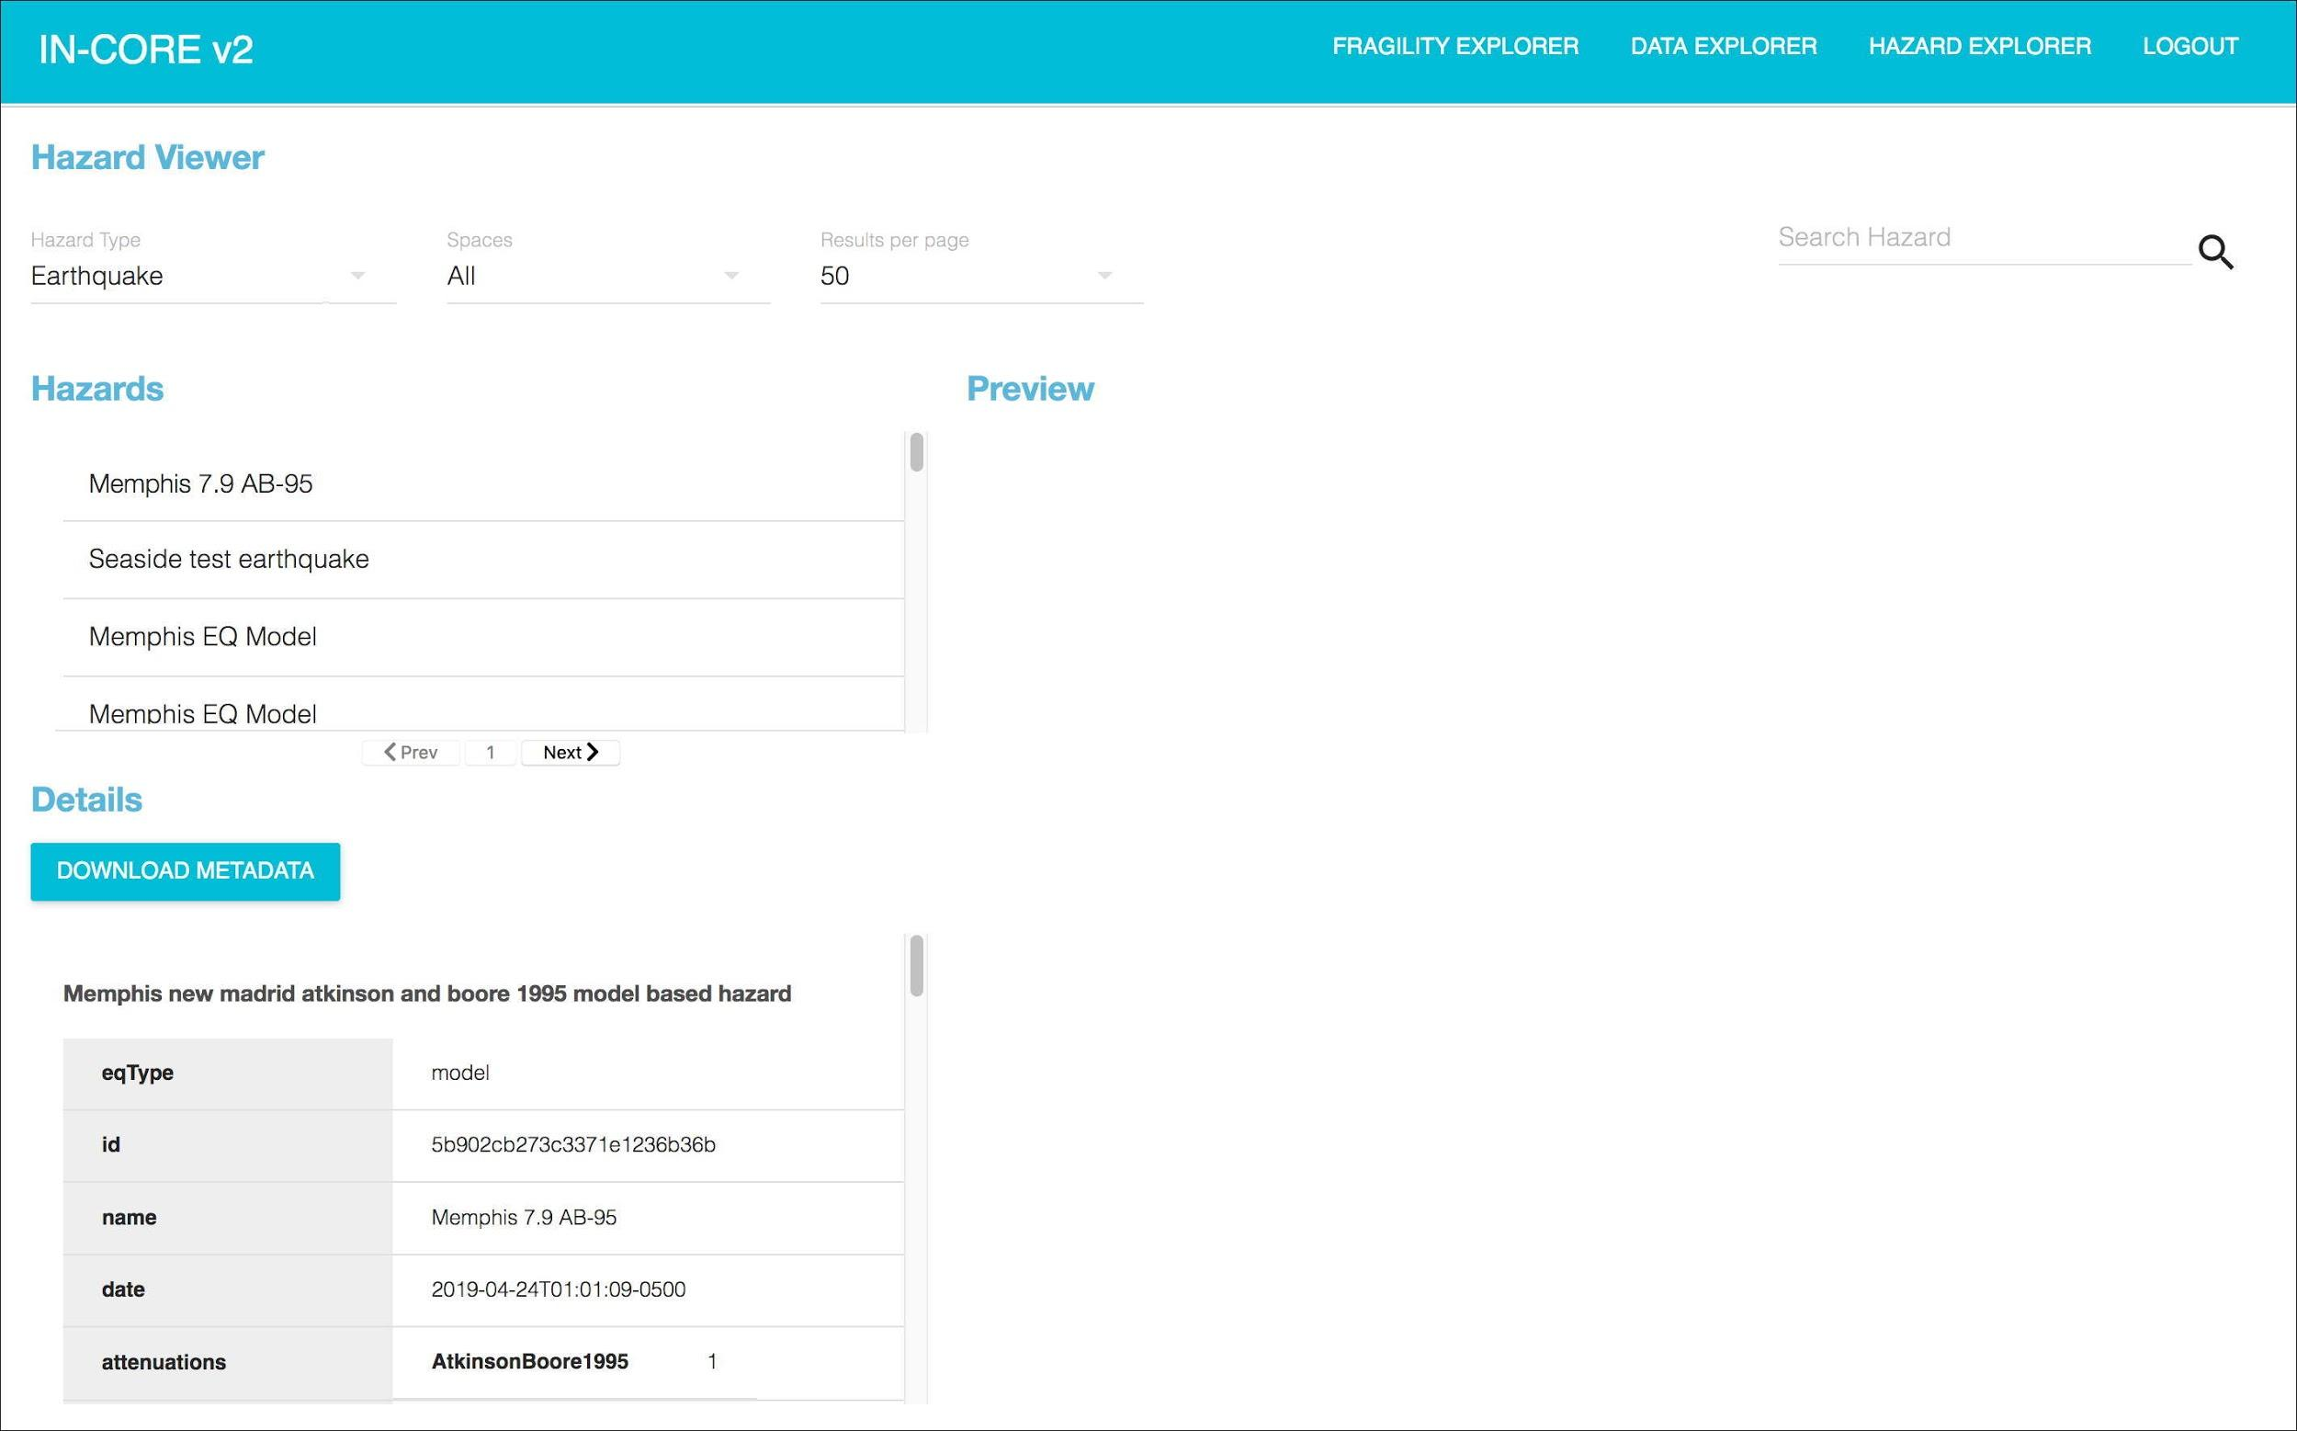

**Data service** viewer.

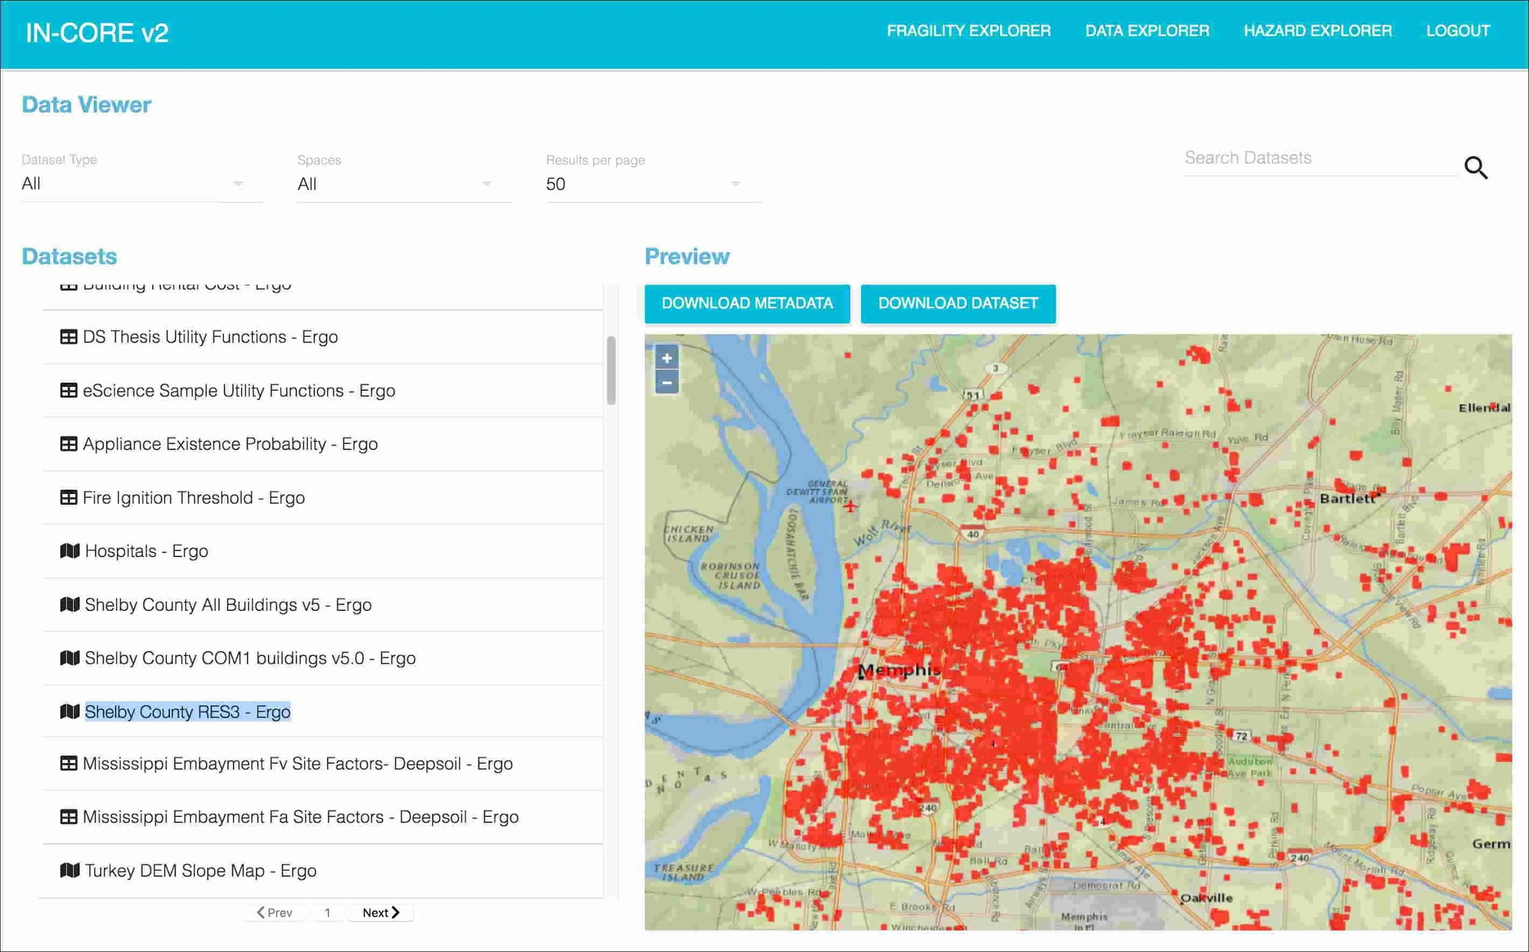

## Additional Information about IN-CORE Lab

This section shows how to access IN-CORE Web Tools and documentations on IN-CORE Lab.

* Click on “INCORE Login” button as shown below.

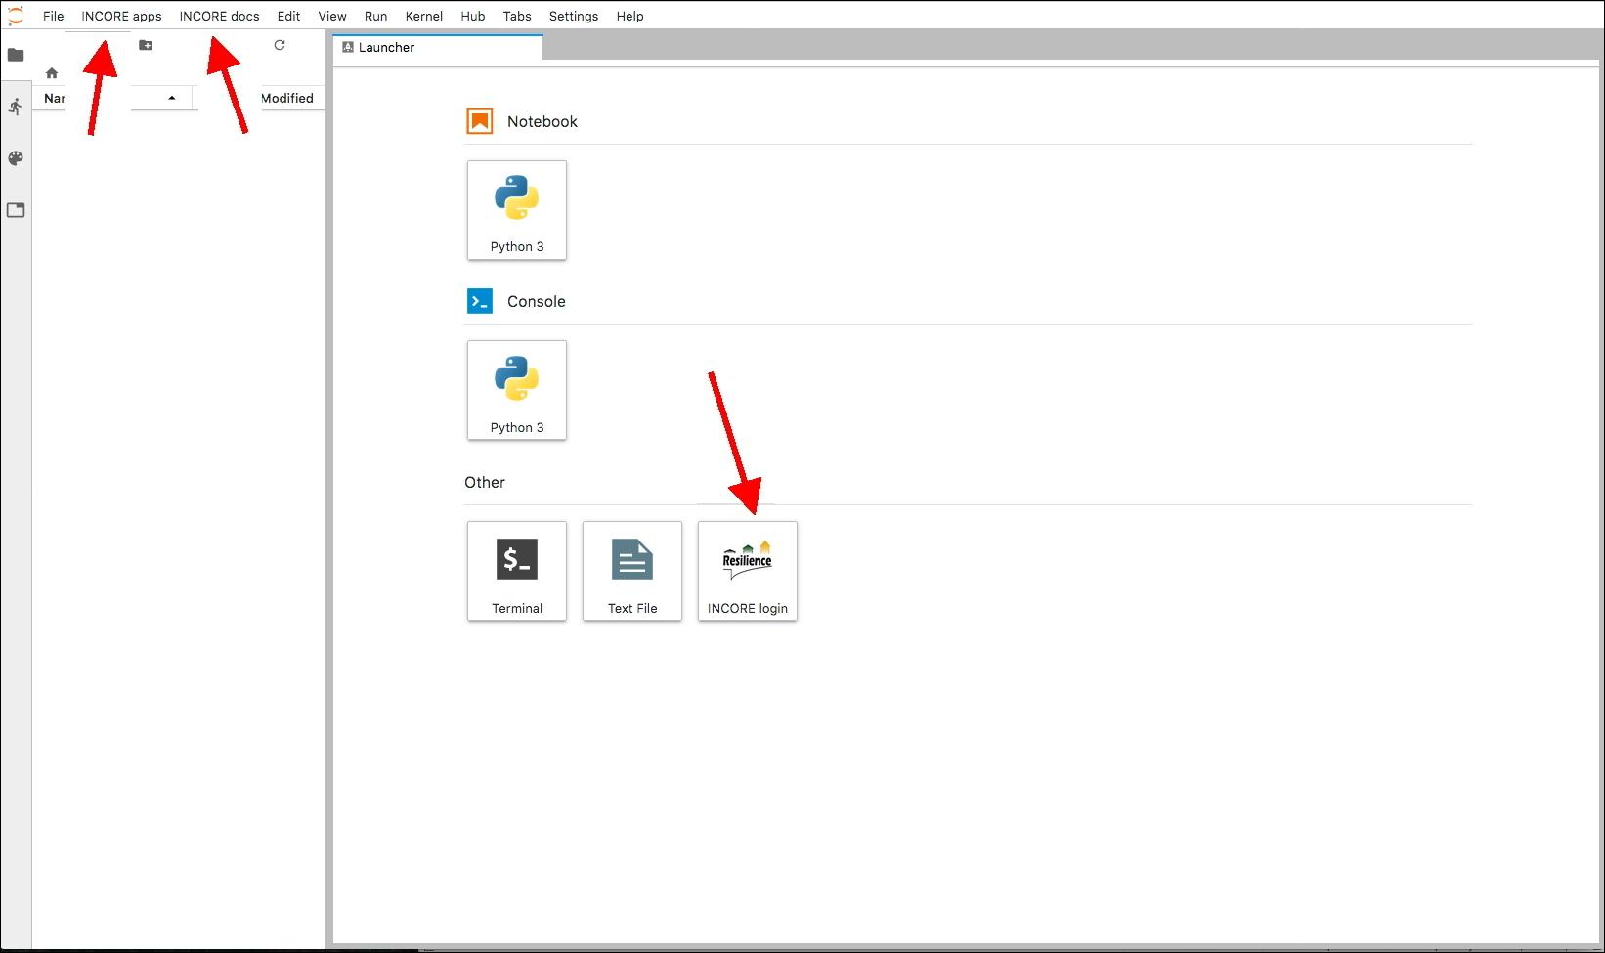

Same username and password for this part.

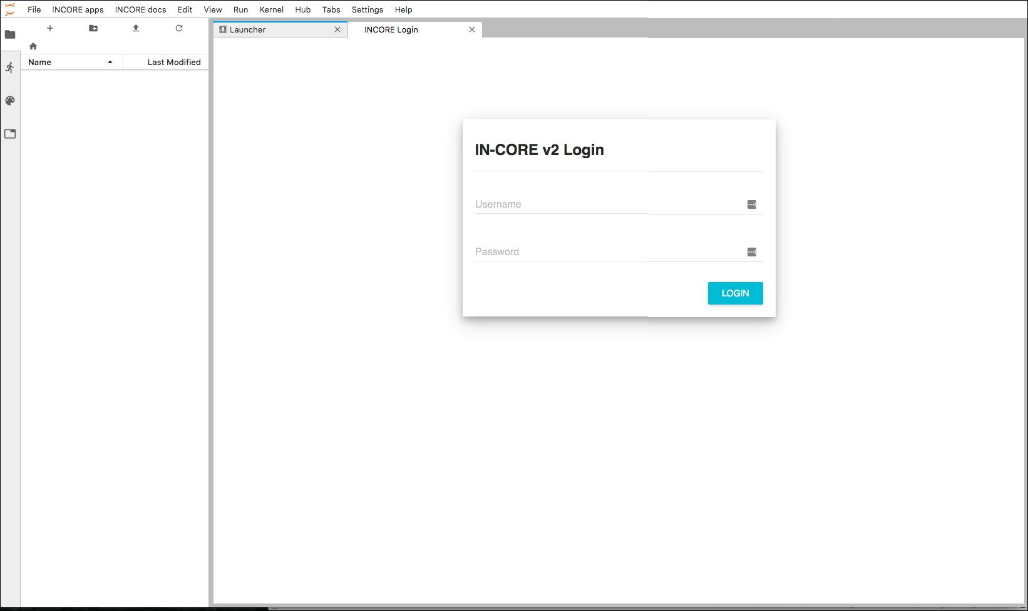

This login process generates a file named **user.json**. Itappears in the File list manager on the left side. The file contains an authentication token required for development of new analyses using IN-CORE’s Application programming interface (API).

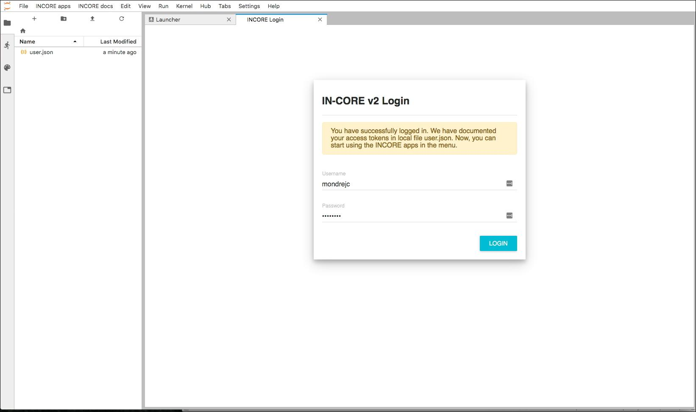

Fragility, Data and Hazard Explorers under INCORE apps menu become enabled after pressing LOGIN button AND reloading the current page in the browser. **NOTE:** A user must reload the whole Jupyter dashboard page (above) using the Reload button of the browser, not the Refresh File List (part of Jupyter’s file navigation) otherwise a following Warning appears:

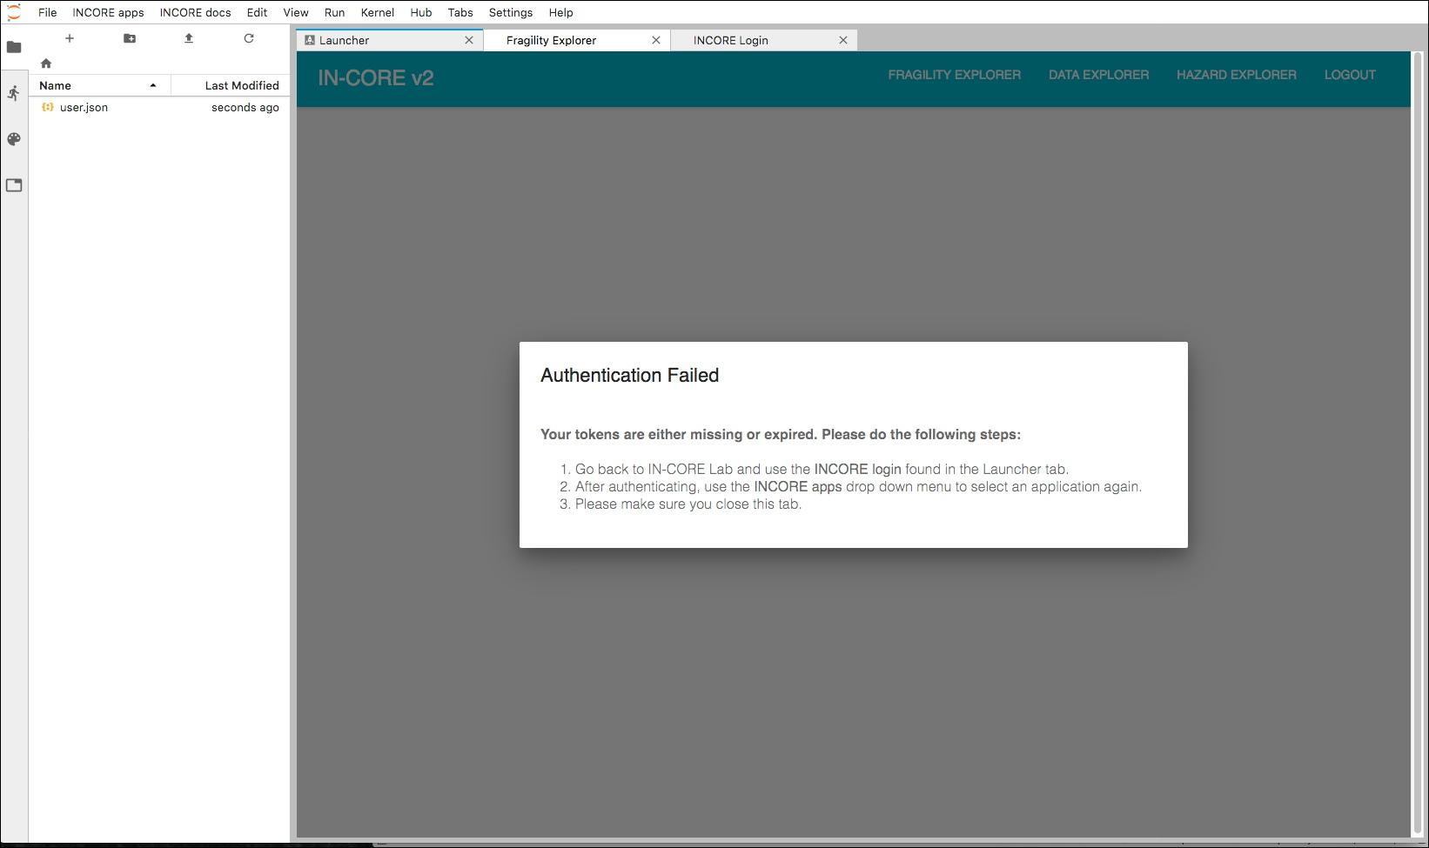

Viewer as part of INCORE Lab as shown below.

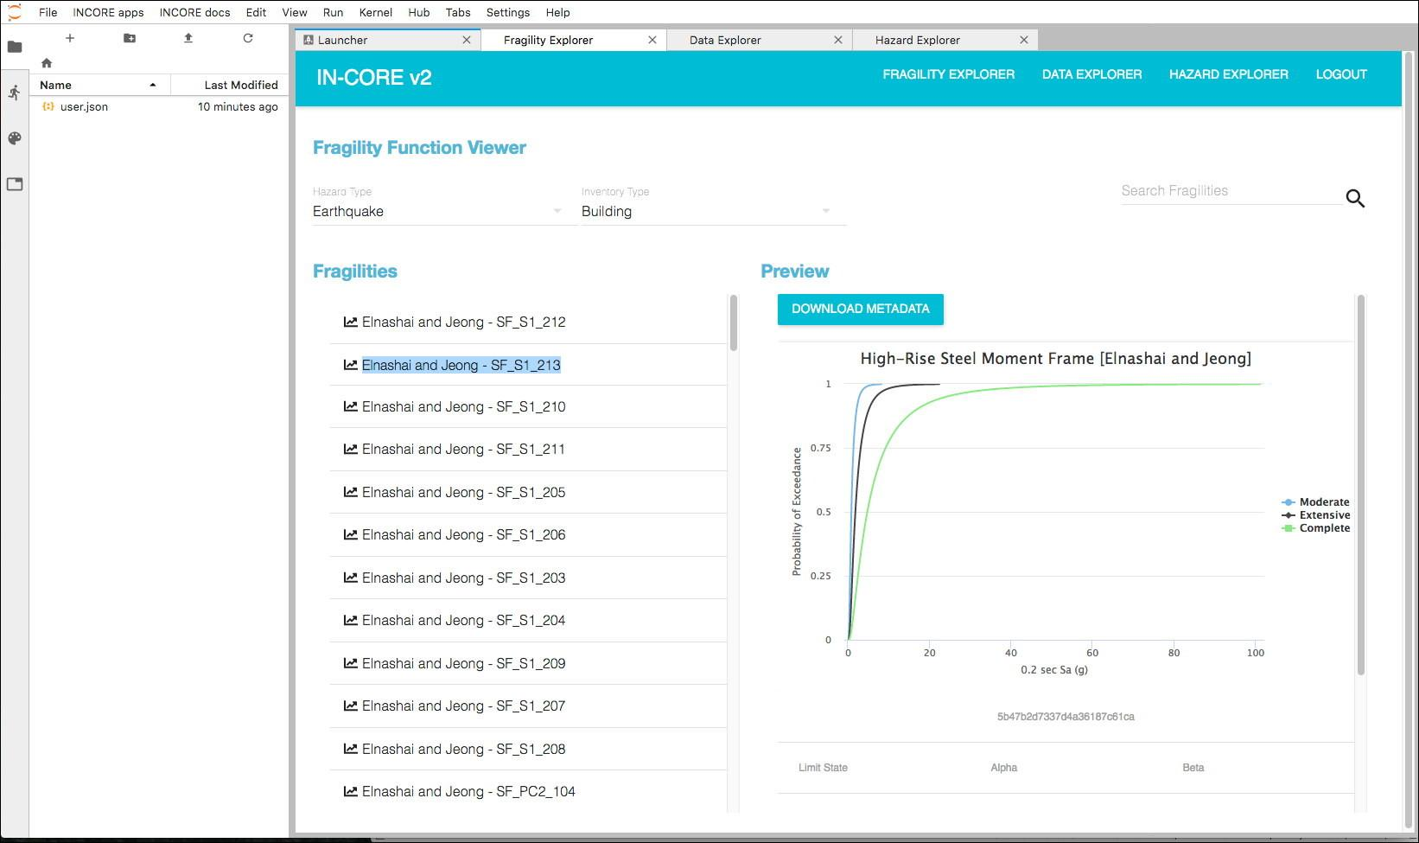 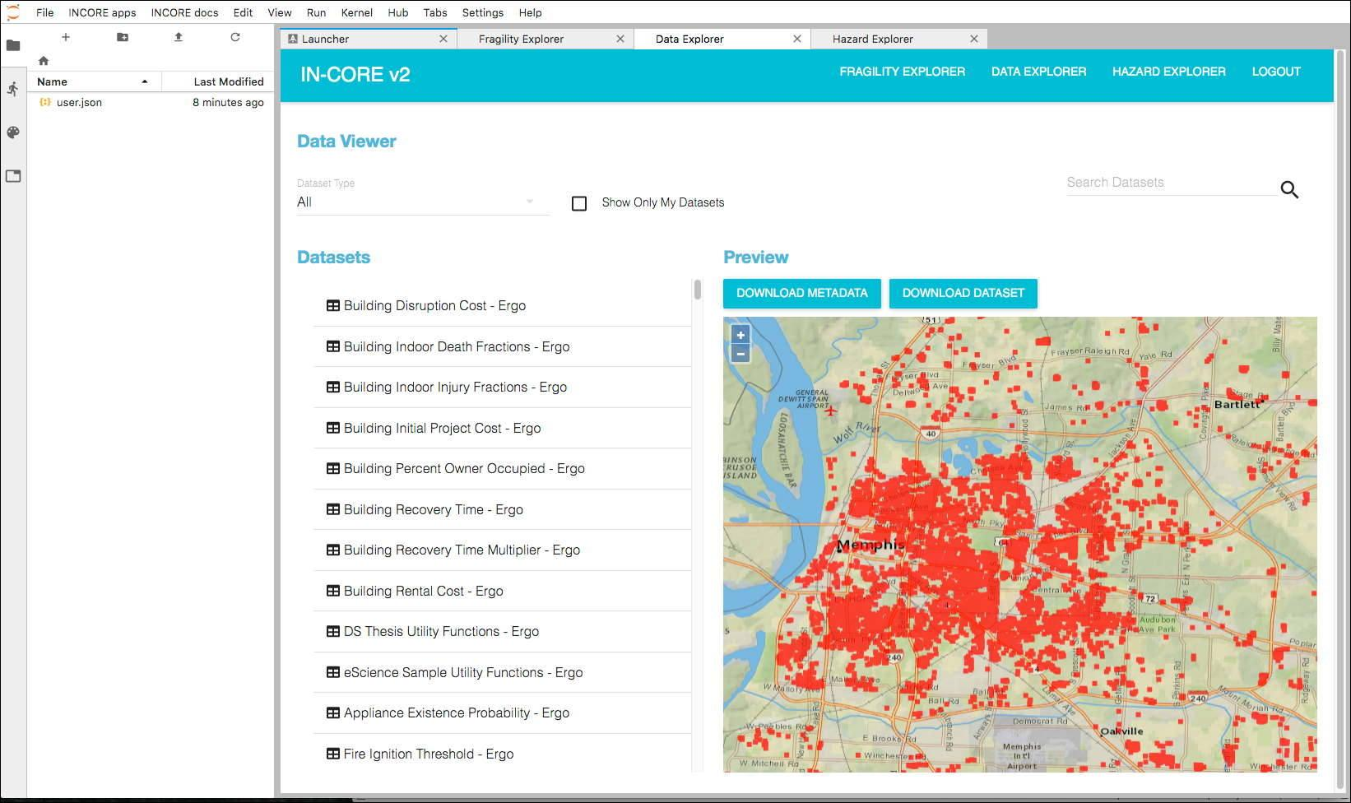

* The second IN-CORE menu (INCORE docs) allows user to see pyIncore documentation and API endpoints definitions for accessing Fragility, Data and Hazard server(s). Another IN-CORE login window opens up at the top of the browser’s main window.

For ease of access - documentation is easily accessible from IN-CORE Lab.

